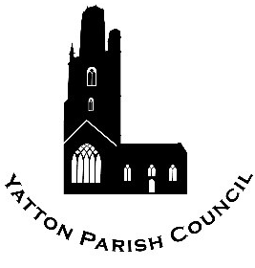 | Yatton Parish Council  Hangstones Pavilion,  Stowey Road,  Yatton  Bristol  BS49 4HS  Tel: 01934 838971  www.yatton-pc.gov.uk | 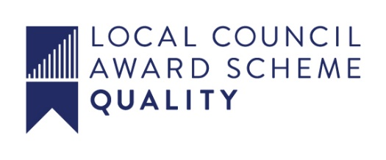

OUR MISSION: To ensure the provision of high quality services in our communities of Yatton and Claverham

Date: 11 May 2021
Clerk: Aleana Baird

Email: clerk@yatton-pc.gov.uk

A MEETING OF THE FINANCE, PERSONNEL AND ADMINISTRATION COMMITTEE WILL BE HELD ON MONDAY 17th MAY 2021 AT 7.30 p.m. IN HANGSTONES PAVILION, STOWEY ROAD, YATTON BS49 4HS.

ALL COUNCIL/COMMITTEE MEETINGS ARE OPEN TO THE PUBLIC
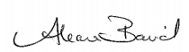

Aleana Baird – Clerk to the Council

A G E N D A

MATTERS FOR DECISION

1. To elect a Chair of Committee for the ensuing year.

2. To elect a Vice Chair of Committee for the ensuing year.

3. To receive apologies for absence

4. To receive councillors’ declarations of interests and consider any written applications for dispensations (the Committee may only grant a dispensation to enable a member to speak in public participation)

PUBLIC PARTICIPATION

5. To receive and hear any person who wishes to address the Committee.

The Chairman of the Committee will select the order of the matters to be heard. Each speaker will be limited to a period of three minutes (to a maximum of 15 minutes total public participation at the Chairman’s discretion).

MATTERS FOR DECISION

6. To confirm the minutes of the meeting held on 19th April 2021.

7. If the Committee wishes to exclude the public for a particular agenda item, the following resolution must be passed:

‘That the public be excluded from the meeting during consideration of agenda item(s) … on the ground that publicity would be prejudicial to the public interest [by reason of the confidential nature of the business] or [for other special reason which must be stated].’

8. Finance
To authorise payments, to note receipts and petty cash payments for May 2021.

9. To review the Health & Safety Policy.

10. To review the Internal Auditors Report 2020-21.

MATTERS FOR INFORMATION

11. To receive the Clerk’s Report

12. Future agenda items

**Members are reminded that the Council has a general duty to consider the following matters in the exercise of any of its functions: Equal Opportunities (race, age, gender, sexual orientation, marital status and any disability) Crime & Disorder, Health & Safety and Human Rights**

THIS DOCUMENT CAN BE MADE AVAILABLE IN A DIFFERENT FORMAT ON REQUEST

