 | Yatton Parish Council  Hangstones Pavilion,  Stowey Road,  Yatton,  Bristol  BS49 4HS  Tel: 01934 838971  www.yatton-pc.gov.uk | 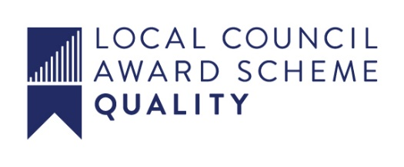

OUR MISSION: To ensure the provision of high quality services in our communities of Yatton and Claverham

Date: 12th May 2020
Clerk: Aleana Baird

Email: clerk@yatton-pc.gov.uk

A MEETING OF YATTON PARISH COUNCIL WILL BE HELD ON MONDAY 18th MAY 2019 AT 7.30 p.m. USING

https://zoom.us/j/589050719

If you're unable to join the meeting via the Zoom app you can join by phone (audio only!) Dial 0203 481 5237 or 0203 481 5240 then enter 589050719# when prompted.

ALL COUNCIL/COMMITTEE MEETINGS ARE OPEN TO THE PUBLIC WHO MAY ALSO JOIN THE MEETING USING EITHER OF THE METHODS ABOVE.
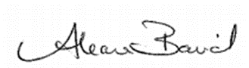
Aleana Baird – Clerk to the Council

A G E N D A

Prayers

MATTERS FOR DECISION

1. To receive apologies for absence, and to approve reasons where appropriate.

2. To receive declarations of interests by Parish Councillors and to consider any written applications for dispensations.

PUBLIC PARTICIPATION

3. To receive and hear any person who wishes to address the Council.

The Chairman will select the order of the matters to be heard. Each speaker will be limited to a period of three minutes (to a maximum of 15 minutes total public participation at the Chairman’s discretion).

North Somerset Council - Ward Councillors’ Reports
Parish Liaison Officer Report
Police Report
MATTERS FOR DECISION

4. To confirm the minutes of the meeting held on 9th March 2020.

5. If the Council wishes to exclude the public for a particular agenda item, the following resolution must be passed:

‘That the public be excluded from the meeting during consideration of agenda item(s) … on the ground that publicity would be prejudicial to the public interest [by reason of the confidential nature of the business] or [for other special reason which must be stated].’

6. Finance

i) To authorise payments, including to note receipts and petty cash payments for May.

ii) To agree section 1 of the accounts for the Parish Council 2019-20 and sign
Section 1 of the Annual Return 2019-20. (Annexe 1 attached)

iii) To agree section 2 of the accounts for Parish Council 2019-20 and sign
Section 2 of the Annual Return 2019-20. (Annexe 2 attached)

7. To consider moving the Meadowland dog bin 25 metres further along Arnolds Way.

8. To approve the Statement of Internal Control for the financial year end to 31st March 2020.

MATTERS FOR INFORMATION

9. To receive the Clerk’s Report.

10. Future Agenda Items.

**Members are reminded that the Council has a general duty to consider the following matters in the exercise of any of its functions: Equal Opportunities (race, age, gender, sexual orientation, marital status and any disability) Crime & Disorder, Health & Safety and Human Rights**
This document can be made available in a different format on request

