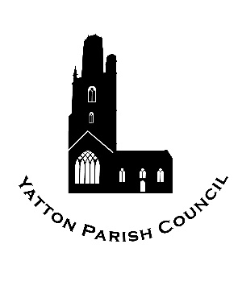 | Yatton Parish Council  Hangstones Pavilion,  Stowey Road,  Yatton  Bristol  BS49 4HS  Tel: 01934 838971  www.yatton-pc.gov.uk | 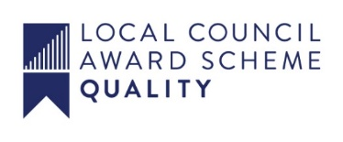

OUR MISSION: To ensure the provision of high quality services in our communities of Yatton and Claverham

Date: 15th Febuary 2022
Clerk: Aleana Baird
Email: clerk@yatton-pc.gov.uk

A MEETING OF THE AMENITIES & PROPERTIES COMMITTEE WILL BE HELD ON MONDAY 21st FEBRUARY 2022 AT 7.30 p.m. AT HANGSTONES PAVILION, STOWEY ROAD, YATTON, BS49 4HS.

ALL COUNCIL/COMMITTEE MEETINGS ARE OPEN TO THE PUBLIC.
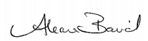

Aleana Baird – Clerk to the Council

Committee Members: Councillors David Crossman, Jonathan Edwards, Wendy Griggs, Graham Humphreys (Vice Chairman), Chris Jackson, Robert Jenner (Chairman), Steven Lister and Massimo Morelli.

A G E N D A

MATTERS FOR DECISION

1. To receive apologies for absence.

2. To receive councillors’ declarations of interests and consider any written applications for dispensations (the Committee may only grant a dispensation to enable a member to speak in public participation).

MATTERS FOR INFORMATION

PUBLIC PARTICIPATION

3. To receive and hear any person who wishes to address the Committee.
The Chairman of the Committee will select the order of the matters to be heard. Each speaker will be limited to a period of three minutes (to a maximum of 15 minutes total public participation at the Chairman’s discretion).

MATTERS FOR DECISION

4. To confirm the minutes of the meeting held on 24th January 2022.

5. If the Committee wishes to exclude the public the following resolution must be passed:

‘That the public be excluded from the meeting during consideration of agenda item(s) … on the ground that publicity would be prejudicial to the public interest [by reason of the confidential nature of the business] or [for other special reason which must be stated].’

6. Parish Gardener and Groundstaff Report.

7. To consider a new flag pole in Glebelands.

8. To discuss parish streetlight maintenance and quotes for repairs to lights on Kingston Bridge and Henley Park.

9. To progress the Queens Platinum Jubilee Celebration ideas including a picnic in the park and the drinking and bottle filling water fountain.

MATTERS FOR INFORMATION

10. To receive the Clerk’s report.

11. Future agenda items.

**Members are reminded that the Council has a general duty to consider the following matters in the exercise of any of its functions: equal opportunities (race, age, gender, sexual orientation, marital status and any disability) crime and disorder, health and safety and human rights** This document can be made available in a different format on request

