

**Your Neighbourhood Policing Team**

**Yatton & Villages**

Newsletter

**February 2021**

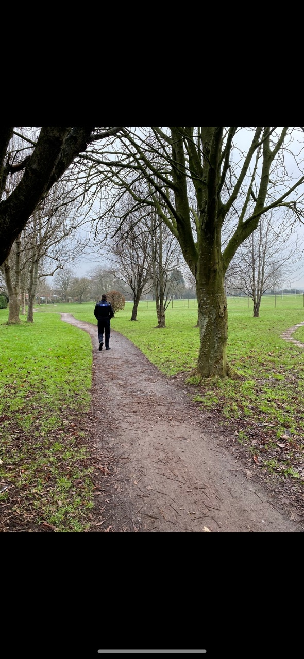

**INSIDE THIS ISSUE**

* **In the News**

*Introducing Gary*

* **Crime Prevention**

*Theft from Motor Vehicle*

* **Crime Statistics**

[](https://www.google.co.uk/url?sa=i&url=https%3A%2F%2Fslack.com%2Fapps%2FA0F7XDW93-twitter&psig=AOvVaw1xRw3blZpDlfzUCKFR_vTA&ust=1590844656271000&source=images&cd=vfe&ved=0CAIQjRxqFwoTCIDk7aeU2ekCFQAAAAAdAAAAABAD)

**Keep in Touch**

**Twitter –** @ASPNorthSom

In the News

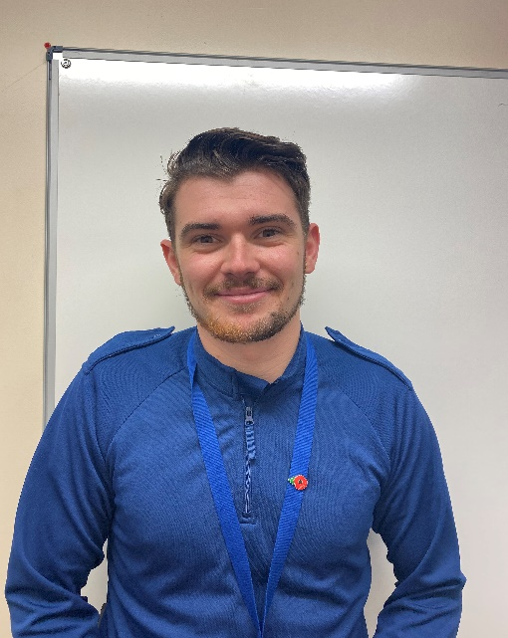

**Hello from me!** I’m Gary Knox. Welcome to the February Newsletter. As mentioned in the December newsletter I joined the team on the 9th of December. In the first few months of my role I have been able to get out and about in Yatton and the surrounding areas, but due to the situation that faces us all at the moment I haven’t been able to meet as many people as I would have liked. If you see me please don’t hesitate to say hello.

**A bit about me!** It’s always been a dream of mine to work for the police and to have managed that is something I am very proud of. I look forward to my career and being able to get involved within the community.

In the past I have worked in upholstery doing hotel and pub refits. I got to travel the country and visit some truly beautiful areas, however North Somerset has the best of both worlds. We have our lovely villages, beautiful hills and country side, as well as the beaches in the towns that surround us.

Starting in a community based role during times where we are unable to meet and hold Beat Surgeries has been challenging as I haven’t been able to get as involved, but we are still around in the communities doing patrols and dealing with any issues.

In case it was missed in the previous letter here are the teams contact details, however if there is an emergency please do call 999 or 101.

Sgt 3494 Pete Rooke – [peter.rooke@avonandsomerset.police](mailto:peter.rooke@avonandsomerset.police)

PC 2974 Jen Clark – [jenny.clark@avonandsomerset.police.uk](mailto:jenny.clark@avonandsomerset.police.uk)

PCSO 7308 Rachel Sellars – [Rachel.sellars@avonandsomerset.police.uk](mailto:Rachel.sellars@avonandsomerset.police.uk)

PCSO 7168 Elle Hicks – [Eleanor.hicks@avonandsomerset.police.uk](mailto:Eleanor.hicks@avonandsomerset.police.uk)

PCSO 8545 Gary Knox – [Gary.knox@avonandsomerset.police.uk](mailto:Gary.knox@avonandsomerset.police.uk)



A gentle reminder ……

You must stay at home. The single most important action we can all take is to stay at home to protect the NHS and save lives. You should follow this guidance immediately.

You must not leave, or be outside of your home except where necessary. You may leave the home to:

* shop for basic necessities, for you or a vulnerable person
* go to work, or provide voluntary or charitable services, if you cannot reasonably do so from home
* Exercise with your household (or support bubble) or one other person (in which case you should stay [2m apart](https://www.gov.uk/government/publications/coronavirus-covid-19-meeting-with-others-safely-social-distancing/coronavirus-covid-19-meeting-with-others-safely-social-distancing)). Exercise should be limited to once per day, and you should not travel outside your local area.
* meet your [support bubble](https://www.gov.uk/guidance/making-a-support-bubble-with-another-household) or [childcare bubble](https://www.gov.uk/guidance/making-a-childcare-bubble-with-another-household) where necessary, but only if you are legally permitted to form one
* seek medical assistance or avoid injury, illness or risk of harm (including domestic abuse)
* attend education or childcare - for those eligible

Crime Prevention

[](https://www.google.com/imgres?imgurl=https%3A%2F%2Fst.depositphotos.com%2F1742172%2F4820%2Fv%2F950%2Fdepositphotos_48206829-stock-illustration-cartoon-padlock-and-key.jpg&imgrefurl=https%3A%2F%2Fdepositphotos.com%2F48206829%2Fstock-illustration-cartoon-padlock-and-key.html&tbnid=z-7XLdc4NMj6MM&vet=12ahUKEwjS7Y3PoLnuAhVMYBoKHRCbCIEQMyg6egQIARBM..i&docid=TEex-Oa6oPO69M&w=1024&h=1024&q=padlock%20cartoon&hl=en-US&ved=2ahUKEwjS7Y3PoLnuAhVMYBoKHRCbCIEQMyg6egQIARBM)

Unfortunately there has been a spate of theft from motor vehicles in nearby Clevedon and Portishead. (Please see section on statistics below for more information).

Theft from a motor vehicle crime prevention advice

* Lock doors, windows, the boot and sunroof every time you leave your car, even for short periods.
* Don’t leave bags, coats or change on display. The cost of replacing a broken window is often far more than the value of goods stolen. If you can, take your things with you. If you can’t, lock everything out of sight in the boot.
* Never leave driving documents or personal letters inside your car. They could help a thief to sell your car or provide a cover story if stopped by the police.
* Don’t leave satnavs on display when you’re not in your car.
* Never set your address in your satnav for your start or return journeys, use an area near to your home you know – if your keys are stolen a criminal may use your satnav setting to direct them to your home.
* Keep valuables out of sight while you’re driving and consider keeping the doors locked.
* Take the ignition key out even when the car is parked in your drive or garage and always set the immobiliser. If you don’t have an immobiliser, consider having one fitted.
* Always keep your keys in a safe place at home, away from windows and doors and preferably in a locked cupboard or cabinet.

Consider leaving your glovebox open when you are not in the car to show there is nothing of value insideer your new property free on [www.immobilise.com](http://www.immobilise.com/)  Install tracking and security apps on relevant electrical and computer products.

Statistics

We had several reports from Claverham in the early hours of the 11th January with people reporting they had seen via their CCTV that two people were seen trying to gain entry to their vehicles. Thankfully nothing was stolen on this occasion.

In addition to the above, just a couple of incidents to make you aware of:

* Garage breaks in Yatton (nothing stolen)
* Commercial burglary in Kenn where by high value items have been stolen.

We have worked proactively to make people aware of recent crimes in the towns by carrying out letter drops in Claverham and Yatton. We have had some feedback to say that it has encouraged people to check their cars are locked and view CCTV to see if it shows any incidents. The whole of Your Neighbourhood Team spent two days in Portishead and Clevedon carrying out high visibility patrols and delivering leaflets which was well received and we are pleased to say we have had no further incidents in the last week. There has also been arrests in relation to the vehicle crime in both towns.

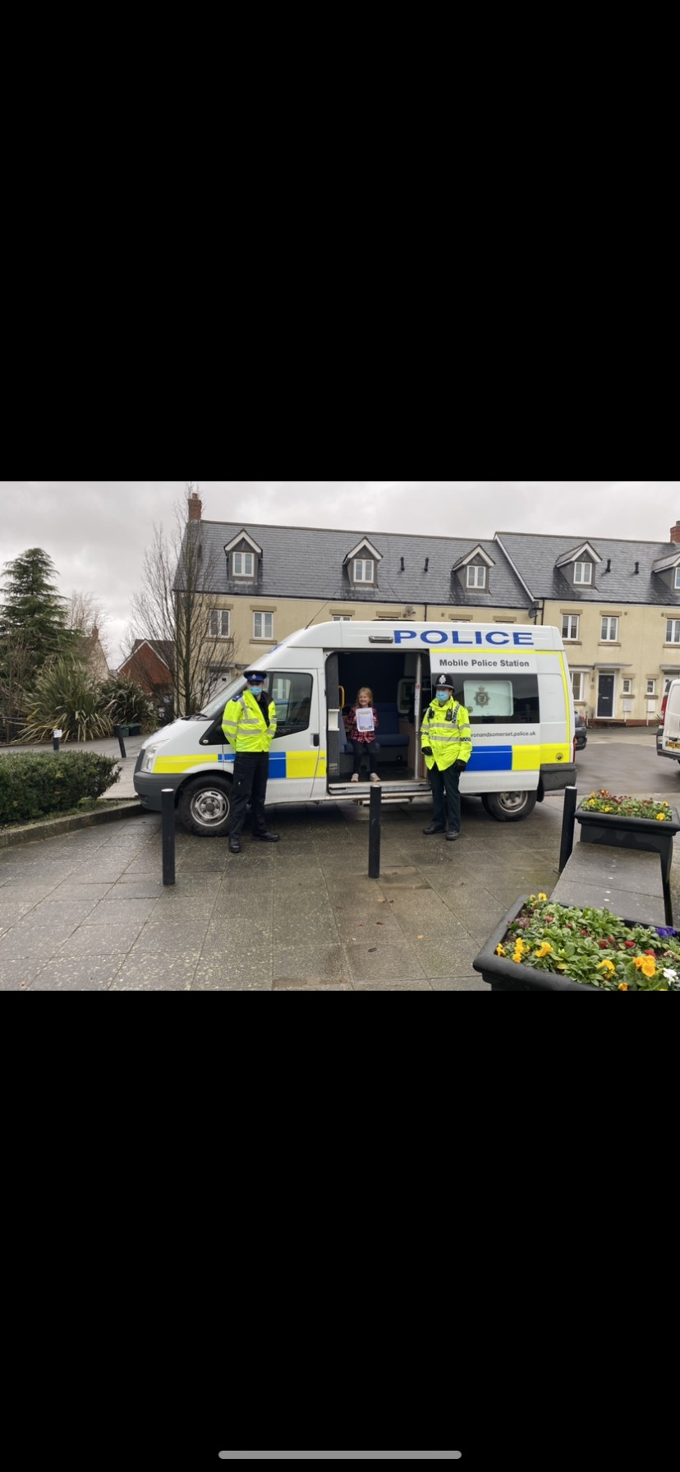

(Portishead Village Quarter)