WORDS ALIVE!

An evening for adults to celebrate WORDS on Cadbury Hill.

Bring a poem or prose to share by heart or read aloud, written by yourself or by another, try out something new or share an old favourite or come as audience.

An opportunity to meet local author Tina M Edwards editor of ‘The Beach Hut’ an online poetry site www.writingatthebeachhut.org who will also be sharing an extract from her new book ‘The Secret of Creek Cottage’.

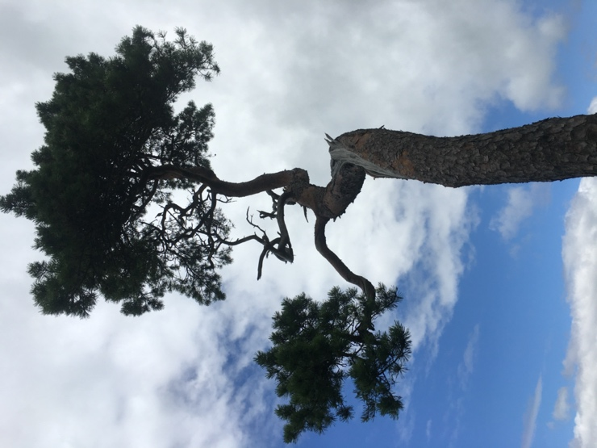

“As morning was dawning and Dylan was yawning, he skipped with mouth wide open and words stuck upon his tongue, he relished sucked and spoke them having so much fun… words to to savour, words in all their flavour” Dylan and the Sea

Sunday 30th August
Meet at Henley Lane car park BS49 4JP at 6.30pm to walk up the Hill
Estimated finish time 8.30pm bring refreshments if you wish

Places will be limited to 20 so please confirm your attendance by contacting Michael Loader at foolworks@yahoo.co.uk

The event will be operating under outdoor performance Covid 19 guidelines

- Please don’t attend if you are showing Covid 19 symptoms
- Social distancing will be adhered to
- Hand sanitiser to be brought by all participants and supplied by organisers
- A risk assessment will be sent to attendees, Yatton and Congresbury parish councils
- Permission has been granted by the Cadbury Hill estate management team

Organised by https://www.facebook.com/4-Communities-3-Trees-1-Hill-Green-Arts-Wellbeing-105716987856676/ Funded by the Arts Council Emergency Fund

