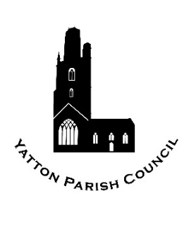 | Yatton Parish Council  Hangstones Pavilion,  Stowey Road,  Yatton  BS49 4HS  Tel: 01934 838971 | 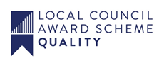
Our Mission – ensuring the provision of high quality services in our communities of Yatton and Claverham

Yatton Parish Council
Volunteer of the Year Award 2025
The Award will be made to an unpaid worker who has given time and effort “beyond the call of duty” for any parish voluntary organisation, club, society or recreational group. In exceptional circumstances the Award may be given to an individual who serves the community outside of group membership. You may nominate yourself if you have a person willing to act as a referee for you.
If you nominate a volunteer, please could you inform the Parish Office if the individual will be attending the meeting. This is simply so that if they are selected as the winner we will know if they will be there in person to collect the award.

PLEASE RETURN THIS FORM BY Friday 7th March 2025 TO:
The Clerk, Hangstones Pavilion, Stowey Road, Yatton, BS49 4HS or admin@yatton-pc.gov.uk

Name and address of volunteer

(Address is so we can send out certificates if they are not collected on the evening).

Name of organisation (s) in which they serve

Name and contact details of a person willing to give an independent reference (unrelated to the person you are nominating)

Name and Contact details of Nominator

Why do you think the person you have nominated deserves recognition for the voluntary service he/she gives to the community? (not more than 200 words please) A sheet of paper may be attached to this form if you prefer, but please attach firmly with staple to this form.

