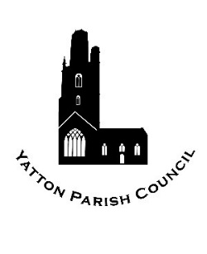

Application Form for Permission to Sell Alcoholic Drinks at Hangstones Pavilion

Please return this form to:

Yatton Parish Council, Hangstones Pavilion, Stowey Road, Yatton, Bristol BS49 4HS

Tel: 01934 838971 | Email: clerk@yatton-pc.gov.uk | Web: www.yatton-pc.gov.uk

Details of Applicant

|  |  |
| --- | --- |
| **Organisation requesting permission:** |  |

|  |  |
| --- | --- |
| **Nature of meeting or event:** |  |

|  |
| --- |
| **Date(s) for which permission requested:** |

|  |  |  |  |
| --- | --- | --- | --- |
| **Start date:** |  | **End date:** |  |

|  |
| --- |
| **Times of day for which permission requested:** |

|  |  |  |  |
| --- | --- | --- | --- |
| **Start time:** |  | **End time:** |  |

|  |  |
| --- | --- |
| **Full name of individual completing form:** |  |

|  |  |
| --- | --- |
| **Position in organisation:** |  |

Notes

By signing this form, you confirm that:

* **All individuals serving alcohol are aware of Sections 141, 146 and 147 of the Licensing Act 2003. Briefly, these state that an individual commits an offence if they sell alcohol to an individual aged under 18, or knowingly sells or attempts to sell alcohol to a person who appears to be intoxicated. Both the person selling alcohol and the licence holder are liable to prosecution; if convicted, these offences carry a maximum penalty of a £5,000 fine and/or 6 months imprisonment;**
* That you will implement a Challenge 21 policy, whereby any purchaser of alcohol who appears to be under 21 will be asked to show photographic proof of identity and birthdate;
* You have authority to sign on behalf of the organisation named above;
* You have read and will abide by the attached Terms and Conditions for the hire of Hangstones Pavilion.

|  |  |  |  |
| --- | --- | --- | --- |
| **Signed:** |  | **Date:** |  |

|  |  |
| --- | --- |
| Date received: |  |

|  |  |
| --- | --- |
| Date authorised: |  |

|  |  |
| --- | --- |
| Authorised by: |  |

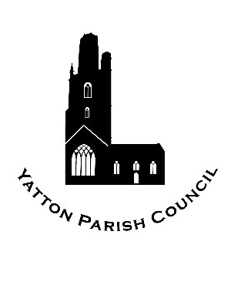**Yatton Parish Council**

Hangstones Pavilion

Stowey Road

Yatton

Bristol

BS49 4HS

Tel: 01934 838971

Email: clerk@yatton-pc.gov.uk

*OUR MISSION: To ensure the provision of high quality services in our communities of Yatton and Claverham*

Privacy Notice

1. When You Contact Us

The information you provide (personal information such as name, address, email address, phone number, organisation) will be processed and stored to enable us to contact you and respond to your correspondence, provide information and/or access our facilities and services. Your personal information will be not shared or provided to any other third party.

1. The Council’s Right to Process Information

General Data Protection Regulations Article 6 (1) (a) (b) and (e):

* Processing is with the consent of the data subject, or;
* Processing is necessary for compliance with a legal obligation, or;
* Processing is necessary for the performance of a task carried out in the public interest or in the exercise of official authority vested in the controller.

1. Information Security

Yatton Parish Council has a duty to ensure the security of personal data. We make sure that your information is protected from unauthorised access, loss, manipulation, falsification, destruction or unauthorised disclosure. This is done through appropriate technical measures and appropriate policies. Copies of these policies can be requested.

We will only keep your data for the purpose it was collected for and only for as long as is necessary. After which it will be deleted. (You many request the deletion of your data held by Yatton Parish Council at any time).

1. Children

We will not process any data relating to a child under 13 without the express consent of their parent or guardian.

1. Access to Information

You have the right to request access to the information we have on you. You can do this by contacting our Data Controller: The Parish Clerk, Hangstones Pavilion, Stowey Road, Yatton, BS49 4HS. Tel: 01934 838971, email clerk@yatton-pc.gov.uk.

1. Information Correction

If you believe that the information we have about you is incorrect, you may contact us so that we can update it and keep your data accurate. Please contact: The Parish Clerk, Hangstones Pavilion, Stowey Road, Yatton, BS49 4HS, tel: 01934 838971, email clerk@yatton-pc.gov.uk, to request this.

1. Information Deletion

If you wish Yatton Parish Council to delete the information held about you please contact: The Parish Clerk, Hangstones Pavilion, Stowey Road, Yatton, BS49 4HS, tel: 01934 838971, email clerk@yatton-pc.gov.uk, to request this.

1. Right to Object

If you believe that your data is not being processed for the purpose it has been collected for, you may object. Please contact: The Parish Clerk, Hangstones Pavilion, Stowey Road, Yatton, BS49 4HS, tel: 01934 838971, email clerk@yatton-pc.gov.uk, to object.

1. Rights Related to Automated Decision Making and Profiling

Yatton Parish Council does not use any form of automated decision making or the profiling of individual personal data.

1. Conclusion

In accordance with the law, we only collect a limited amount of information about you that is necessary for correspondence, information and service provision. We do not use profiling and we do not sell or pass your data to third parties. We do not use your data for purposes other than those specified. We make sure that your data is stored securely. We delete all information deemed to be no longer necessary. We review our Privacy Policies to keep them up to date in protecting your data. You can request a copy of our policies at any time.

1. Complaints

If you have a complaint regarding the way your personal data has been processed you may make a complaint to the Parish Clerk, Hangstones Pavilion, Stowey Road, Yatton, BS49 4HS, tel: 01934 838971, email clerk@yatton-pc.gov.uk and/or to the Information Commissioner’s Office: tel 0303 123 1113; email casework@ico.org.uk.