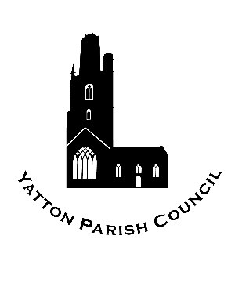 | Yatton Parish Council  Hangstones Pavilion,  Stowey Road,  Yatton  Bristol  BS49 4HS  Tel: 01934 838971  Email: clerk@yatton-pc.gov.uk | 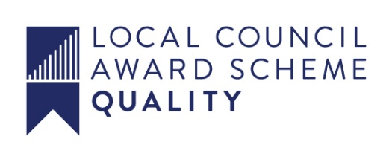

OUR MISSION: To ensure the provision of high-quality services in our communities of Yatton and Claverham.

Application for Cremation Wedge Burial Register No:

In memory of the late ..................................................................................................................

of .................................................................................................................................................

......................................................................................................................................................

Died: ......................................................................

Purchaser’s Name: .........................................................................................................................

Address: ....................................................................................................................................

......................................................................................................................................................

Date: ..............................................

Monumental Mason: …………………………………………………………………………………………
______________________________________________________________________________

Fee Received: ..............................................

Date: ............................................................

