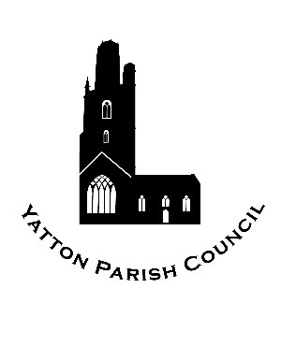 | Yatton Parish Council  Hangstones Pavilion  Stowey Road  Yatton  Bristol  BS49 4HS  Tel: 01934 838971  Email: clerk@yatton-pc.gov.uk | 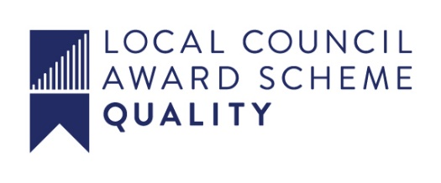

OUR MISSION: To ensure the provision of high quality services in our communities of Yatton and Claverham

Yatton Parish Council
Community Infrastructure Levy Financial Report 2018-19

Town and Parish Councils are required under Regulation 62A of the Community Infrastructure Regulations to report on the income and expenditure of CIL funds received in each financial year.

Community Infrastructure Levy Received –

1st April 2018 – 30th Sept 2018
NIL

Oct 1st 2019 – March 31st 2020
£1,710.97 - Paid April 17th 2019

Total Received: £1,710.97

Community Infrastructure Levy Expenditure

NIL

Community Infrastructure Levy Balance at March 31st 2019 - £1,710.97

The balance at March 31st 2019 was placed in an Ear Marked Reserve and
must be spent by 17th April 2024.

